**HACKATHON PROJECT**

Software Requirements Specification

|  |  |  |  |
| --- | --- | --- | --- |
|  | **Prepared By** | **Reviewed By** | **Approved By** |
| **Name** | Tecnotuners |  |  |
| **Role** | GenC |  |  |

**Table of Contents**

1. Introduction…………………………………………………………………..…1

1.1 Intended Audience……………………………………………….......1

1.2 Project Scope…………………………...……………………………1

2. Overall Description…………………………………………….……………….1

2.1 Operating Environment……………………...……………………....1

3. Requirements……………………………………………………………...…….1

3.1 Description………………………………………………....2

3.2 Functional Requirements……..…………………………...2

**1. Introduction**

MakeMyTrip is an Indian online travel website that provides online travel services. We are taking and testing three functionality of that website (i.e.)  Book one way outstation cab(from Delhi to Manali), fill card details in Gift Cards, and on the Hotel booking page, extract all the numbers for Adult persons.

**1.1 Intended Audience**

* Business Unit (BU) SME
* Academy coach
* Technical Trainer

**1.2 Project Scope**

This document defines at a functional level the business activities that are encompassed by the system and the rules that apply to them. It also encompasses some of the key high and low level technical requirements of the system.

It draws heavily on both proposed Framework and Business Rules and the Technical Architecture documents. The scope of the detailed analysis project phase specifies that this document will include.

* Classification of requirements according to their functional areas.
* A description of each process in the system, including their inputs, outputs, and data transformation rules.

**2. Overall Description**

**2.1 Operating Environment**

* Windows operating system
* Web application

**3. Requirements**

**3.1 Description**

This part of the requirements document serves to present the "MakeMyTrip for Outstation Cab" and " MakeMyTrip for Gift Cards”, and “MakeMyTrip for numbers of Adult persons” functionalities of the application.

**3.2 Functional Requirements**

**3.2.1 Req0001**

**Req0001a-** Select “cabs”

**Req0001b** -Select the “OUTSTATION ONE-WAY” radio button

**Req0001c**-Enters the text as “Delhi” in “From” search bar and selects “Delhi,India” from the auto suggestion list box.

**Req0001d**- Enters the text as “Manali” in “To” search bar and selects “Manali, Himachal Pradesh” from the auto suggestion list box.

**Req0001e-** Select any “future date” from Departure calendar.

**Req0001f-** In Pick time dropdown, Select “6:30 AM”.

**Req0001g-** Clickon “Search” button. It will navigate to next page.

**Req0001h-** Select “SUV” from car type in select filters.

**Req0001i-** Select “Price (Lowest to Highest)” in Sorted By drop down list.

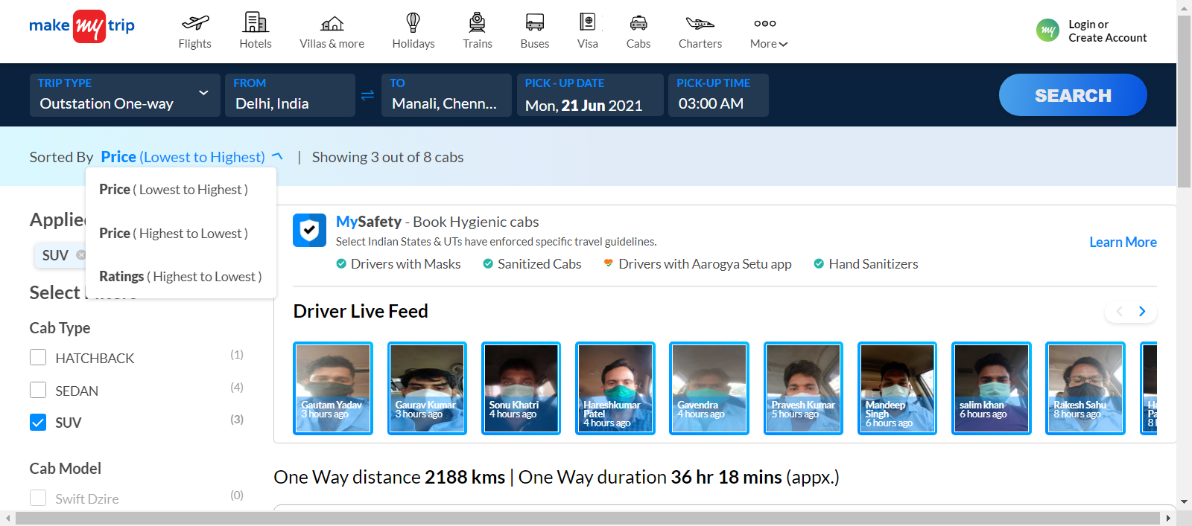

**3.2.2 Req0002**

**Req0002a**- Go to home page by clicking on “Makemytrip” logo

**Req0002b-** Click on “More” option and select “Gift cards” from dropdown list and it will navigate to gift card page.

**Req0002c-** Click on Buy E-Gift card” button. It will navigate to gift card details

page.

**Req0002d-** Fill “Gift card Details” and “Sender and Receiver Details”.

**Req0002d-** Enter invalid email to “Email Address” text box of Sender Details and Receiver Details.

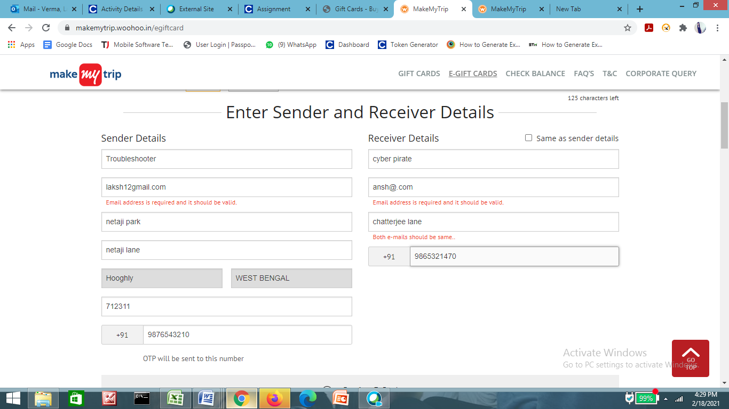

**3.2.3 Req0003**

**Req0003a**- In home page of Makemytrip, click on “hotels”

**Req0003b-** Click on “ROOMS & GUESTS” dropdown list. It will display all the numbers for Adult persons

